# Wee Beasties

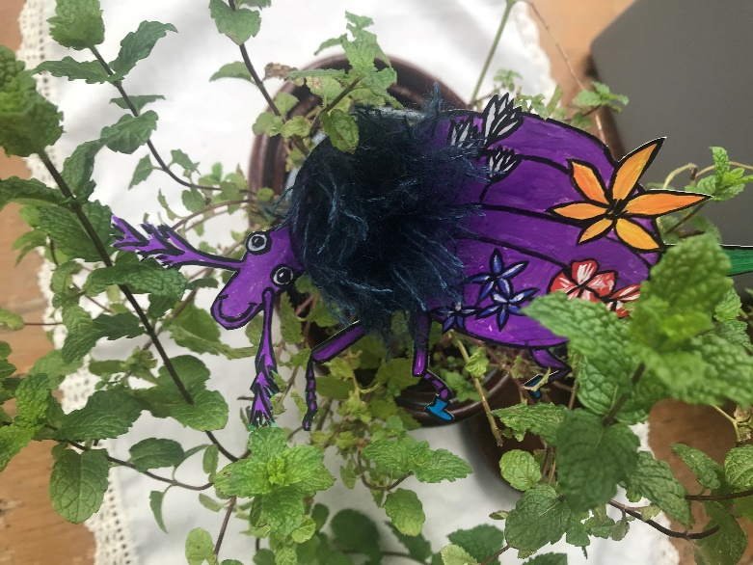

The Wee Beasties project is aimed at P7 – S2 pupils studying in Scottish schools. The aim of this project is to involve school pupils in COP 26. We will invite these pupils to invent their own ‘Wee Beastie’ who will experience climate change, and then come to the University of Glasgow on a mission to discover how university study and research could help combat climate change.

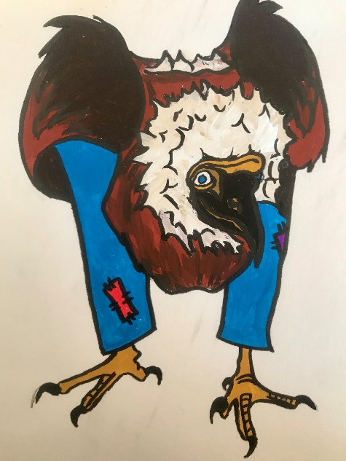This project is designed to be inclusive, with young people able to engage at a level and in a manner that suits them. Designing a Wee Beastie will engage young people’s imagination and creativity, while exploring the impact of climate change on their imaginary creature will increase knowledge and emotional engagement with an issue that can seem too complex, too distant, or too overwhelming. The university visit for pupils will allow them to see themselves (by proxy through their own Beastie) attending a university and working to solve one of the world’s greatest problems.

This project will also allow pupils to see their own creative and intellectual work valued and celebrated through inclusion as part of a website.

Phase one (home or school)

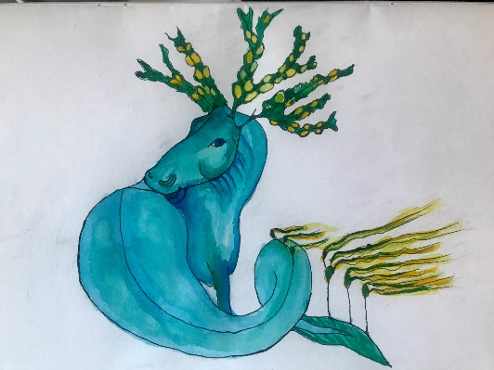Pupils will invent a creature to live in a local environment. They will draw a picture of their beastie on some card, cut it out, and take it to the place they feel it should live. They will take a picture and upload the picture of the beastie in its natural habitat, along with some writing about their beastie and where it lives.

Phase two (school)

Beasties are in trouble because of climate change! Pupils will receive lessons about climate change and will be encouraged to reflect on how their beastie might be affected. Independent study and research will be encouraged to build on the foundations laid by direct teaching on climate change.

Phase three (university visit/virtual visit)

Beasties at university – pupils will be reassured that their beastie is a clever beastie and can learn to do things about climate change. Through a school visit or an online experience, pupils will have the chance to take their beastie to university. They will explore all the different ways that university study and research might help combat climate change, such as learning more about them, learning how to persuade people to listen and care about climate change, learning how to use the law to make people and governments act on climate change, learning how to use technology to combat issue, learning how similar problems have been combatted historically. Pupils will identify an area of university study or research that fits their beastie and take a photograph of their beastie in that environment.

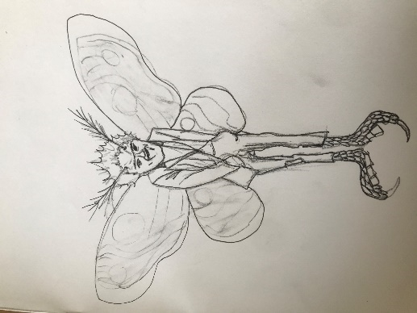Phase four (school)

On their return to school, pupils will write a description of what their beastie might learn at university that will help with climate change, and upload this along with the photo of the beastie at university. This will form part of a University of Glasgow map, showing where each beastie is working, and what they are working towards.

## Resources and Logistics

|  |  |  |  |  |  |
| --- | --- | --- | --- | --- | --- |
| Phase | Activity | Experiences and Outcomes | School Resources | University Resources | Covid Contingency Planning |
| Phase 1 | Invent a creature to live in a local environment. Use the map on our website to upload your story about your creature. Draw a picture of your beastie on some card, cut it out, and take it to the place. Take a picture and email the picture of your beastie in its natural habitat along with a description of your beastie. Tell us what makes your beastie’s home a good place for that beastie? | Creativity EXA 2-02a  Awareness of adaptation to fit environment  Digital skills  Literacy LIT 2-20a | Digital camera or smartphone camera  Beastie planning and construction session  Beastie photography session  Beastie pictures and text upload | Website including map which incorporates the beasties submitted by pupils  Sample beasties  Worksheet guide for how to support beastie creation (including information on adaptation to fit environment) | None required – tasks can be accomplished by children working online at home |
| Phase 2 | Beasties are in trouble because of climate change! Think about how your beastie might be affected by climate change. | Learning about climate change SOC 2-08a  Note taking skills LIT 2-15a, TCH 2-01a  Research and information gathering LIT 2-14a, TCH 02-02a, TCH 2-01a | Lessons delivered about climate change  Facilitated discussion about how climate change could affect local environment | Online resources on aspects of climate change  Guidance on how to search for new climate change information relevant to a particular beastie  Worksheet or other pro forma to allow climate concerns to be recorded for each beastie  Information on using Teams for video conferencing | None required– tasks can be accomplished by children working online at home |
| Phase 3 | Beasties at university – your beastie is a clever beastie and can learn to do things about these problems. Take your beastie to university to help them cope with these new problems by learning more about them, learning to persuade other people to listen to the problems, learning how to use the law to make people do something about them, learning how to use computers to record the issues, learning how to invent scientific fixes. | Widening participation HWB 2-12a  Linking education and research to solutions to climate change SOC 2-08a  Reasoning and decision making skills – what would be the most helpful input a particular beastie might make? LIT 2-09a, LIT 2-10a | Resource and organize trip to university during COP 26  Support young people discussion their beastie’s university choices  Support photography of beasties | Tour around campus, including any suitable events being run for COP 26, including photo with wee beastie in the ‘right’ place | Set up website to share videos and descriptions of university colleges and schools from a ‘wee beastie’ perspective  Offer a range of backgrounds onto which beastie images can be easily pasted |
| Phase 4 | Write a description of what your beastie might learn at university that will help with climate change, and upload this along with the photo of your beastie at university | Literacy LIT 2-20a  Creative problem solving SOC 2-08a  Aspiration HWB 2-13a,  HWB 2-19a | Support young people in writing about their experience  Support young people to email images and text for website | Website – create a university map with wee beasties and what they are learning about | None required – tasks can be accomplished by children working online at home |

## Curriculum for Excellence Experiences and Outcomes included in this project

### Literacy across learning

*When listening and talking with others for different purposes, I can: · share information, experiences and opinions · explain processes and ideas · identify issues raised and summarise main points or findings · clarify points by asking questions or by asking others to say more. LIT 2-09a*

*I am developing confidence when engaging with others within and beyond my place of learning. I can communicate in a clear, expressive way and I am learning to select and organise resources independently. LIT 2-10a*

*Using what I know about the features of different types of texts, I can find, select and sort information from a variety of sources and use this for different purposes. LIT 2-14a*

*I can make notes, organise them under suitable headings and use them to understand information, develop my thinking, explore problems and create new texts, using my own words as appropriate. LIT 2-15a*

*I enjoy creating texts of my choice and I regularly select subject, purpose, format and resources to suit the needs of my audience. LIT 2-20a*

### Expressive arts

*I have the opportunity to choose and explore an extended range of media and technologies to create images and objects, comparing and combining them for specific tasks. EXA 2-02a*

### Technologies

*I can extend and enhance my knowledge of digital technologies to collect, analyse ideas, relevant information and organise these in an appropriate way. TCH 2-01a*

*I can use digital technologies to search, access and retrieve information and am aware that not all of this information will be credible. TCH 02-02a*

### Health and wellbeing

*Representing my class, school and/or wider community encourages my self-worth and confidence and allows me to contribute to and participate in society. HWB 2-12a*

*Through contributing my views, time and talents, I play a part in bringing about positive change in my school and wider community. HWB 2-13a*

*Opportunities to carry out different activities and roles in a variety of settings have enabled me to identify my achievements, skills and areas for development. This will help me to prepare for the next stage in my life and learning. HWB 2-19a*

### Social studies

*I can discuss the environmental impact of human activity and suggest ways in which we can live in a more environmentally responsible way. SOC 2-08a*