# My Wee Beastie : Task Outline

## Step One

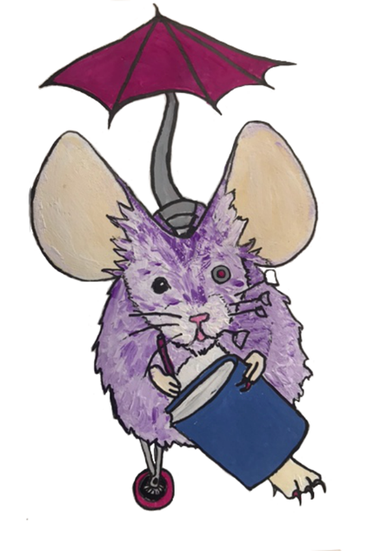

**Draw your beastie and cut them out.**

**Find a place in your local area where your beastie lives. Take your beastie there, and take their photo.**

**Write about your beastie, explaining how they live, what they do, and what their life is like.**

### Help with Imagining

* If you can’t think of a whole new creature, try fitting two real world animals together – how about a lion-mouse? How about a clam-centipede? Or a tiny elephant-bee with wings?
* If you have a real world kind of animal that you love, think about a cool variation on that creature – what sort of robot parts might it have? What would it need to live somewhere close by where it normally can’t live? What if it were amazingly small and needed something special to survive?
* If there is a monster that you really like, think about what if it was crossed with an animal. How about a zombie frog, or a ghost-shrew?

### Help with Writing

* Explain who your beastie is, and what sorts of things they do.
* Do some research to help you describe the environment your beastie lives in.
  + Is your beastie an urban, suburban or rural beastie?
  + What sort of plants, trees, flowers and other creatures live near your beastie?
  + What sort of home does your beastie have?
  + Does your beastie live on land or water?
  + Does your beastie live under ground, in a tree, in the drains beside the pavement, in a pond, in a pool at the seashore, under an old mattress dumped in a field…?
  + How does your beastie fit the environment they live in? What about their body or their habits makes them able to live there?

#### Scottish environmental information

* <https://www.nature.scot/landscapes-and-habitats/habitat-types>
* <https://scottishwildlifetrust.org.uk/scotlands-wildlife/>
* <https://www.nhm.ac.uk/discover/how-water-voles-left-their-riverside-homes-for-glasgow-grassland.html>
* <https://www.nhm.ac.uk/discover/urban-wildlife.html>
* <https://www.froglife.org/info-advice/amphibians-and-reptiles/>

Look for as many more excellent sources of information as you can find!

#### Adaptation to Environment information

* [https://www.nhm.ac.uk/discover/what-is-natural-selection.html](https://www.nhm.ac.uk/discover/news/2021/september/animals-shapeshifting-to-adapt-to-rising-temperatures.html)
* <https://www.nhm.ac.uk/discover/news/2021/september/animals-shapeshifting-to-adapt-to-rising-temperatures.html>
* <https://www.nhm.ac.uk/discover/how-do-camels-survive-in-deserts.html>
* <https://www.nhm.ac.uk/discover/news/2021/september/plants-and-pollinators-use-electric-fields-to-find-each-other.html>

Look for as many more excellent sources of information as you can find!

## Step Two: Researching your Beastie

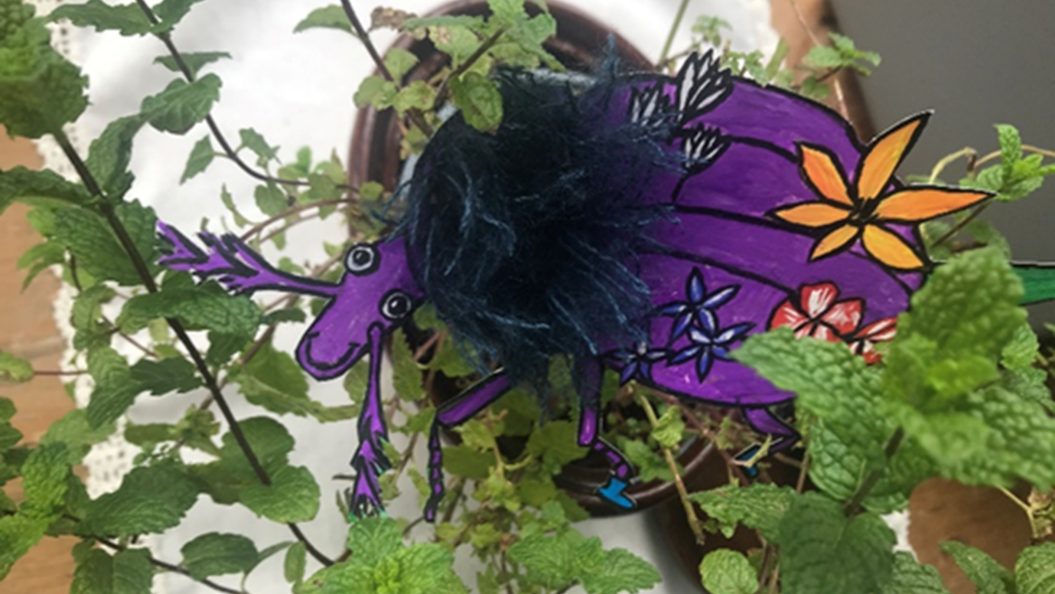

* **Find out about your beastie’s environment. How is it changing?**
* **How does climate change affect your beastie?**
* **What problems does your beastie face?**

### Step Two – help with doing research

Your teacher will give you some websites to get started, but you can also find your own. That will mean you will have to spot which are good websites and which might not be very reliable websites.

Think about:

* + Does the website tell you who wrote it? Do they sound like a reliable person?
  + Does the website have a date to tell you how old the information is?
  + Is the website linked up to a reliable institution, like a university?
  + Does the website give sources for its information?
  + Does the website provide links to evidence?
  + Is the website trying to sell you something?
  + Can you find other websites that agree with this one?

### Step Two – help with writing

* Read about climate change internationally
* Read about climate change in Scotland
* Think about where your beastie lives – which aspects of climate change would affect your beastie?
* Write about where your beastie lives and how climate change will cause them problems

#### Climate Change Information

* <https://www.nhm.ac.uk/discover/anthropocene.html>
* <https://www.invasivespecies.scot/invasive-species>
* <https://www.nhm.ac.uk/discover/will-the-ocean-really-die.html>
* <https://www.nature.scot/doc/naturescot-climate-change-nature-information-sheet>
* <https://www.nature.scot/scotlands-biodiversity/key-pressures-biodiversity>

Look for as many more excellent sources of information as you can find!

#### More Climate Change Information

* <https://www.wwf.org.uk/updates/10-myths-about-climate-change>
* [https://www.oxfam.org/en/what-we-do/issues/tackling-climate-crisis#:~:text=Oxfam%20campaigns%20for%20climate%20action,countries%20are%20supported%20to%20adapt](https://www.oxfam.org/en/what-we-do/issues/tackling-climate-crisis).
* <https://www.adaptationscotland.org.uk/why-adapt/impacts-scotland>
* <https://www.nhm.ac.uk/discover/news/2021/september/animals-shapeshifting-to-adapt-to-rising-temperatures.html>
* <https://www.wwf.org.uk/what-we-do/projects/our-climate-work-scotland>

Look for as many more excellent sources of information as you can find!

## Step Three: Going to University

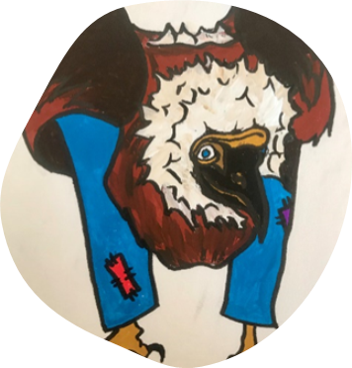

* **Your beastie wants to learn what they can do about climate change. So, you can show them round the University of Glasgow**
* **While you are there, pick what your beastie should learn about to help them deal with climate change**
* **Write about what your beastie will do and why it will help**